Staff Report
Meeting Date: August 1, 2023
To: Siskiyou County Board of Supervisors
From: Bernadette Cizin, Assistant Planner
Subject: Proposed Wildlands Conservancy Williamson Act Rescission with Re-entry, Agricultural Preserve Amendment (APA-22-09) and CEQA Determination

Background and Discussion
On July 29, 2022, the County received an application for a Williamson Act Contract amendment to bring approximately 3720 acres, owned by The Wildlands Conservancy, under one Williamson Act contract consisting solely of property under their ownership with the Agricultural Use of rangeland and pasture for livestock production and forage. The property is currently under one Williamson Act contract, which has multiple property owners. Also, the existing Agricultural Preserve should be amended to remove the subject property and a new Agricultural Preserve created, as the existing preserve is not in line with the current county guidelines.
During the initial review of the project, it was found that one of the subject parcels, APN 031-560-080 is substandard in size (under the 40-acre minimum requirement), and only a portion of a separate parcel is within an Agricultural Preserve. The applicant was notified that at 18 acres, one parcel does not meet the minimum parcel size requirement. Second, land is evaluated by entire legal parcel, therefore a portion parcels, totaling 1018 acres, would not be allowed to remain under contract. The portion parcels and substandard parcel would be recommended for non-renewal. As it is the current policy not to increase the size of an agricultural preserve and due to the configuration of the property owned by the Wildlands Conservancy, staff advised the applicant team to consult with a surveyor about a potential boundary line adjustment to reconfigure the parcels to meet the current parcel size requirements. The applicant informed staff that they would not be pursuing a boundary line adjustment and requested the project be presented to the board with the understanding that staff would be recommending the non-renewal of the substandard and portion parcels.
Agricultural Preserve Administrator Review
Staff prepared a detailed report (Exhibit D) for review and recommendation by the Agricultural Preserve Administrator. Based on the report, the Administrator found the applicant’s request is consistent with the County Rules for the Establishment and Administration of Agricultural Preserves and Williamson Act Contracts and recommends the Board rescind and reissue the contract as proposed and amend the existing preserves to remove the subject property and establish a new agricultural preserve. The Administrator also recommends that the Board direct staff to issue a Notice of Non-Renewal for the 18-acre parcel and portion parcels.

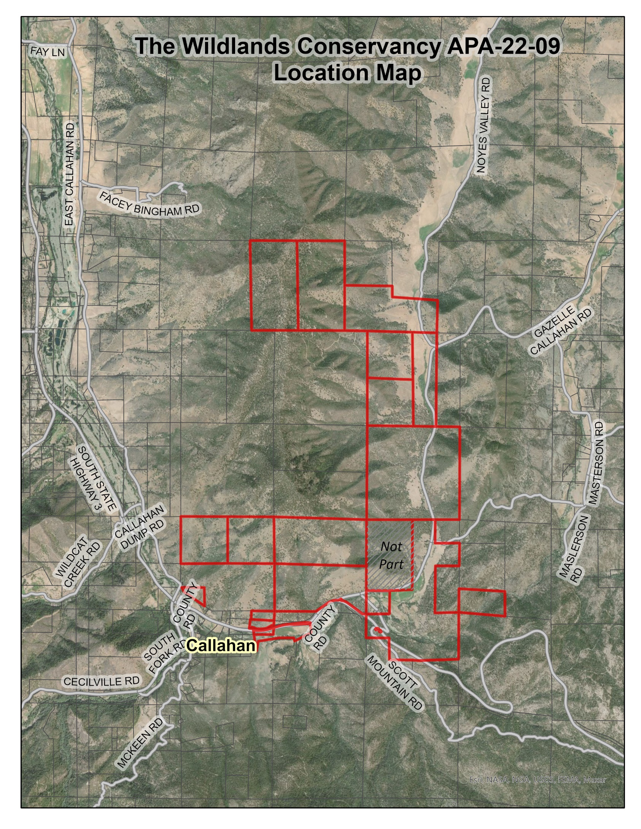
Figure 1: Subject Parcels

Environmental Review
Staff is proposing that the proposed project be considered categorically exempt from the California Environmental Quality Act (CEQA) pursuant to CEQA Guidelines Section 15317, Open Space Easements or Contracts. A Categorical Exemption implies that the project will not result in any significant adverse environmental effects. CEQA Guidelines Section 15317 specifically exempts the making and renewing of open space contracts under the Williamson Act, which is applicable to the subject action.
The Board of Supervisors must consider the proposed CEQA exemption together with any comments received during the public review process. Further, the exemption can only be approved if the Board finds, based on the whole record before it, that there is not substantial evidence that the project will have a significant effect on the environment. Accordingly, a finding to this effect has been incorporated into both draft resolutions prepared for the Board’s consideration.

Comments
Notice of the project was published and posted as required prior to the Board of Supervisors meeting and no public comment was received as of the preparation of this staff report.

Recommended Action
Should the Board of Supervisors concur with staff’s analysis, staff recommends that the Board of Supervisors find that the proposed modifications to the Williamson Act contract and Agricultural Preserve are exempt from CEQA and approve said modifications.
A draft motion to this effect is provided below.

Recommended Motions
I move to take the following actions:
- Determine the project exempt from CEQA in accordance with Section 15317, Open Space Easements or Contracts; and
- Adopt the attached resolution approving amendment to the existing Agricultural Preserve and establishment of a new preserve.
- Adopt the attached resolution approving the rescission and reentry of the applicable Williamson Act contract; and
- Adopt the attached resolution directing staff to process the Notice of Non-Renewal for the 18-acre substandard parcel and portion parcels, with any changes directed by the Board.

Exhibits to the Staff Report
- Draft Resolution amending the existing Agricultural Preserve and establishing a new preserve
- Draft Resolution Approving the Rescission of the subject property from the existing contracts and Reentry into a new Williamson Act Contract
- Exhibit B-1 within Draft Resolution: Williamson Act Contract – Draft
- Draft Resolution directing staff to issue a Notice of Non-Renewal for the substandard parcel and portion parcels
      - Exhibit A within Draft Resolution: Notice of Non-Renewal – Draft
- Agricultural Preserve Administrator Staff Report with Recommendation

